Balance Board

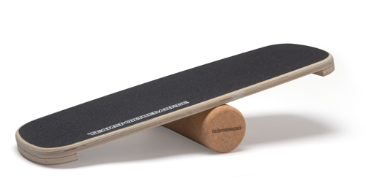

Klasse | Note 2 | Note 1 | Note +1
5. | 20 | 30 | 40
6. | 30 | 40 | 50
7. | 40 | 50 | 1:00
8. | 50 | 1:00 | 1:10
9. | 1:00 | 1:10 | 1:20
10. | 1:10 | 1:20 | 1:30

